# Driving Right (1) in Python

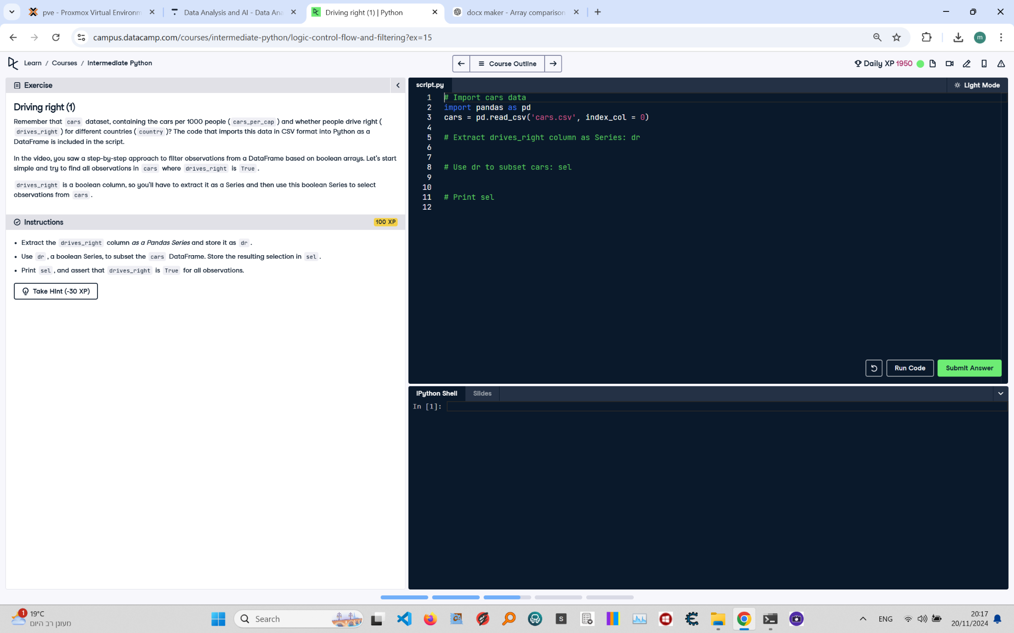

**Question:**

Remember that `cars` dataset contains the cars per 1000 people (`cars_per_cap`) and whether people drive right (`drives_right`) for different countries (`country`). The code that imports this data in CSV format into Python as a DataFrame is included in the script.  
1. Extract the `drives_right` column as a Pandas Series and store it as `dr`.  
2. Use `dr`, a boolean Series, to subset the `cars` DataFrame. Store the resulting selection in `sel`.  
3. Print `sel`, and assert that `drives_right` is `True` for all observations.

**Answer:**

Here is the Python code that solves the problem:

# Import cars data  
import pandas as pd  
  
# Read the dataset  
cars = pd.read_csv('cars.csv', index_col=0)  
  
# Extract drives_right column as Series: dr  
dr = cars['drives_right']  
  
# Use dr to subset cars: sel  
sel = cars[dr]  
  
# Print sel  
print(sel)

**Explanation:**

1. **Import Pandas**: The Pandas library is imported to handle tabular data in a DataFrame.  
2. **Read the dataset**: The `pd.read_csv()` function reads the dataset from a CSV file into a Pandas DataFrame. The `index_col=0` parameter sets the first column as the index.  
3. **Extract `drives_right` column**: The `drives_right` column is extracted as a Pandas Series and stored in `dr`.  
4. **Subset the DataFrame**: The `cars[dr]` expression uses the boolean Series `dr` to filter the rows of the DataFrame where `drives_right` is `True`. The result is stored in `sel`.  
5. **Print the result**: The `print(sel)` statement displays the subsetted DataFrame.